Coversheet
Student Id: cse25-218
Student names: Thabiso Blessing Masalila
Student email: cse25-218@thuto.bac.ac.bw
Cohort: 2026
Assignment title: SCIS WMD_2026 A01
Date of submission: 20/03/2026
Programme of Study: Computer Systems Engineering
Year of Study: Year 1
Intellectual property statement
By checking the box below, I certify that this assignment is my own work and is free from
plagiarism. I understand that the assignment may be checked for plagiarism by
electronic or other means and may be transferred and stored in a database for the
purposes of data-matching to help detect plagiarism. The assignment has not previously
been submitted for assessment in any other unit or to any other institution. I
have read and understood the Botswana Accountancy College plagiarism guidelines
policy.
☐ Agree Signature: B.masalila
Date: 4/15/2026
Part A: Website Specifications, Information Design & Taxonomy, Technical Brief

- Website Specifications
- Website Objectives & Goals:
The objective of Sport Stream is to make a brand that provides information about sports to users worldwide and that users can stream whenever they want and wherever they are.
Purpose:
Promotion and marketing: The website will focus on promoting Sportstream games. That is why Sportstream introduced free limited games so that we turn visitors into users. For users to schedule games for later, they must be subscribers.
Branding and Image: Sportstream’s website design, content and user experience will promote the brand identity by communicating professionalism and creativity.
The goal is to:
- Showcase a wide range of available sports to attract users. To attract and retain diverse user groups. By featuring popular global sports such as soccer, basketball, tennis, formula 1, and boxing, the website ensures that fans of different disciplines find relevant content, encouraging exploration and repeat visits.
- Build trust in the streaming community. By content accuracy, technical reliability, transparent communication, and responsive user engagement
- Provide information about the subscription price so users can know their plans on which subscription they are able to afford and how their payment will go like.

- Target Audience: Sports fans
- Demographics: This primarily targets males and females aged between 18-60. This includes students and anyone of any profession.
- Location: A global audience, with a focus of regions with internet access.
- Technical Aptitude: The audience ranges from tech-savvy young adults who are comfortable with streaming services and online subscriptions, to an older demographic who may be less technical. Therefore, this website helps users to function seamlessly across all devices like smartphones, tablets, and laptops. And to expect high quality visuals at times.
C. Type of Website:
Sportstream website is an informational website and entertainment platform that will feature sports content for sports watchers and lovers. It provides games to be scheduled for later so that users will be reminded of the time when the game starts.

- Information Design & Taxonomy
The website follows a flat hierarchy with clear content categorization, ensuring users reach any page fast.

Site Map
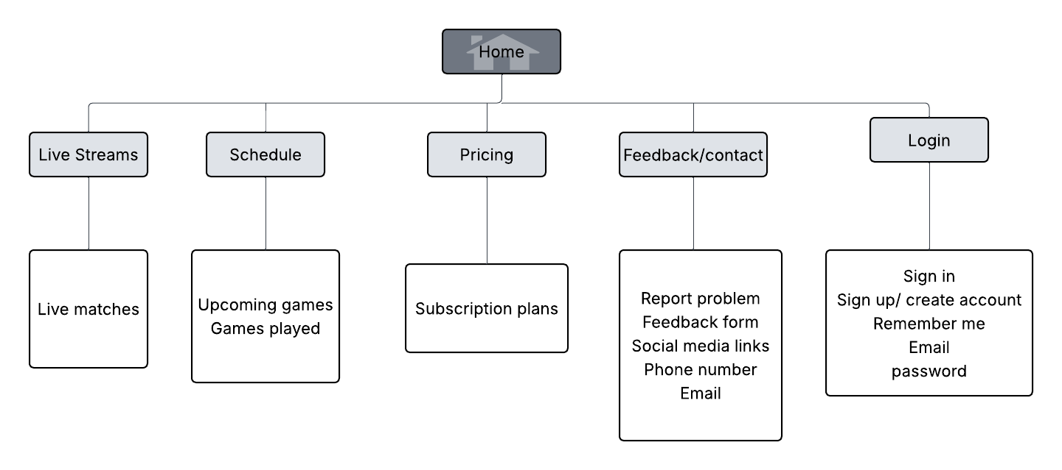

Content Categorization
- Home: Hero banner with current live match, featured events grid, call-to-action for subscription.
- Live Streams: Shows live matches. It will showcase different matches which are still on going.
- Schedule: This will have a filter tab to list games according to sport type and date.
- Pricing: There are Free, Monthly, Annual features and sign-up buttons to users.
- Feedback/Contact: It is for users to share their opinion and report issues or any suggestion regarding our website and contact us when they have issues regarding the website.
- Login: This is where users will login to watch matches or create an account.

- Page Template Design:
SportStream Wireframe
- Below is how the SportStream website will look like.
Home Wireframe:
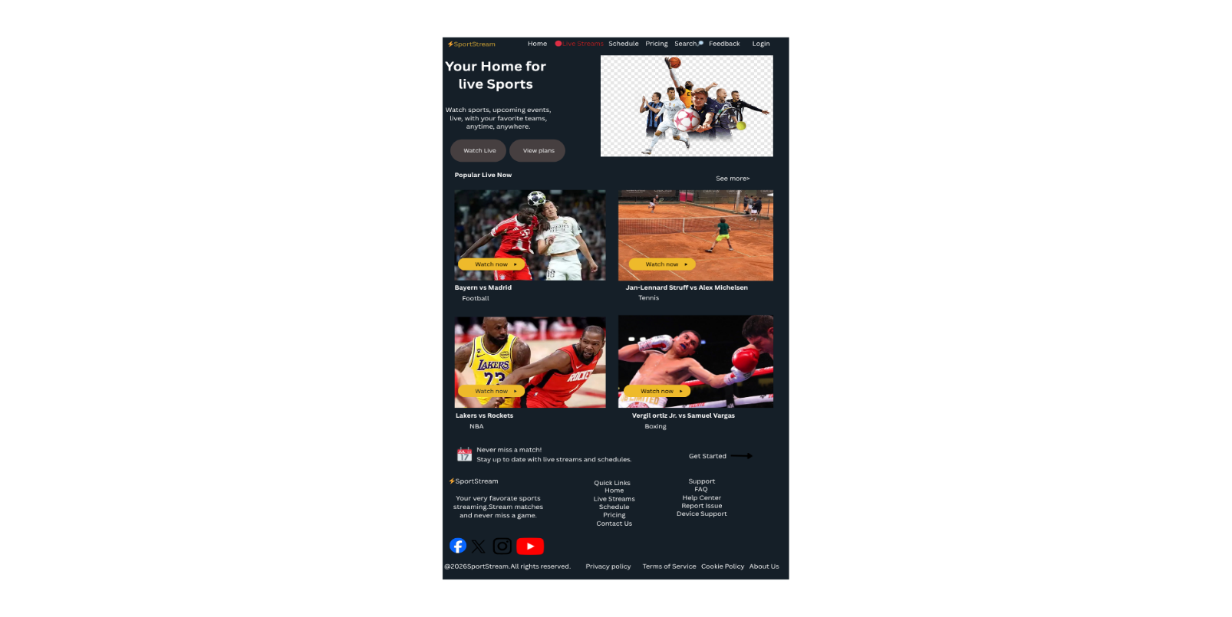
- Live Streams Wireframe:
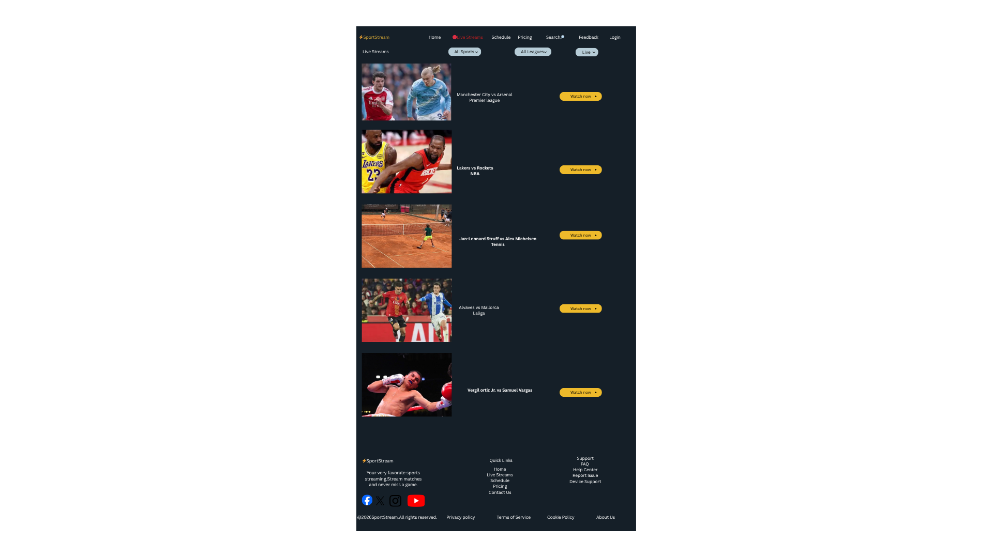

Schedule Wireframe:
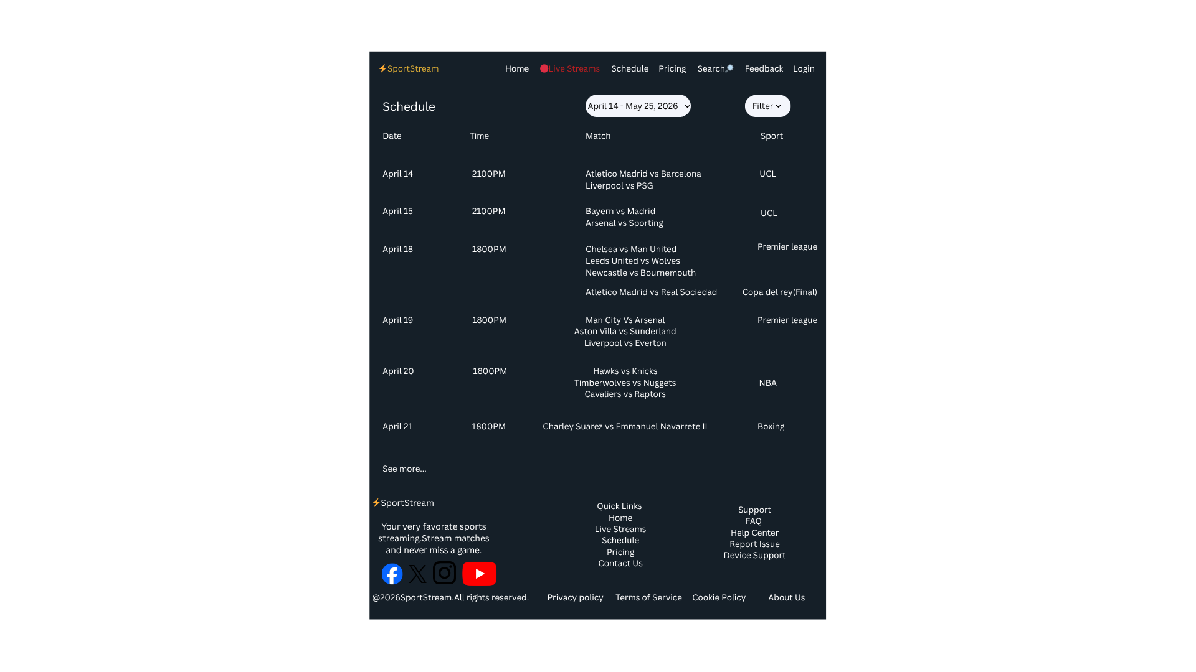

Pricing Wireframe:

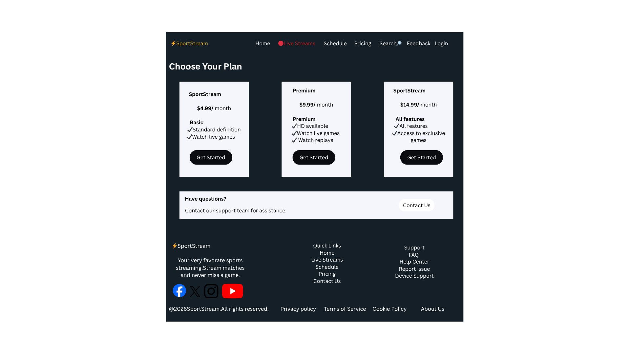

Feedback Wireframe:

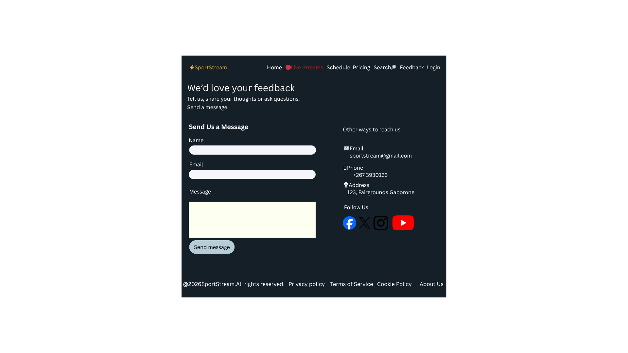

Login Wireframe:

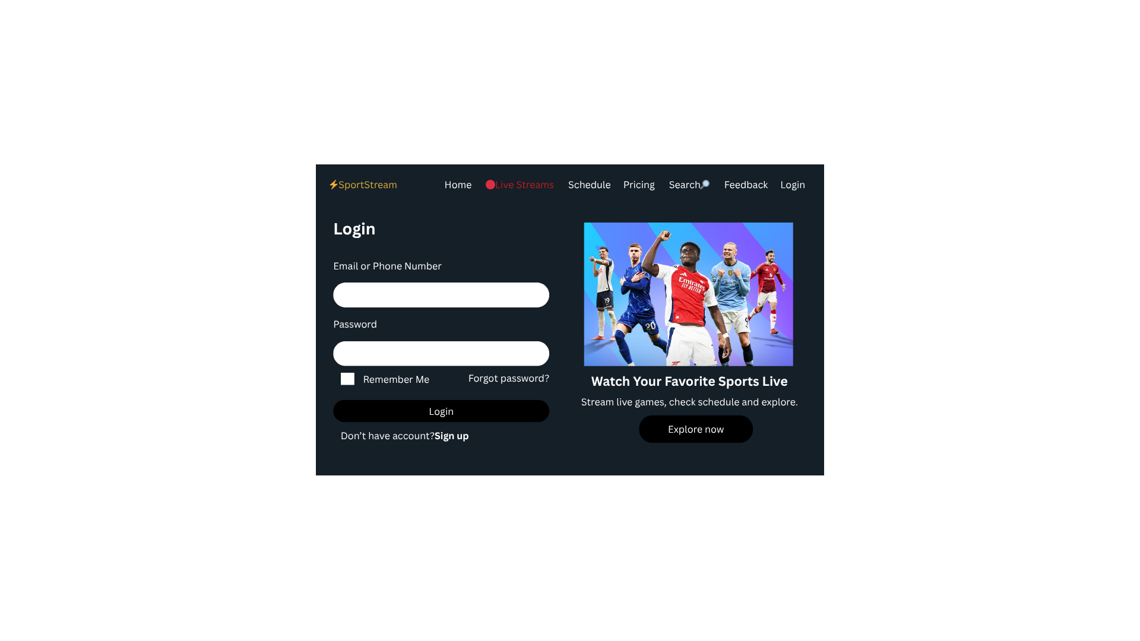

4. Technical Brief:
Technologies:
- HTML5 – Structures the content of web pages. It provides semantic tags like E.g., <header>, <main> that describes each content section.
- CSS3 – Styles to the presentation, including layout, colors and design. And it makes the website easier to maintain.
- Bootstrap – Responsive framework to accelerate layout. Accelerates development by providing ready-to-use navigation bars and forms.
- JavaScript – Used to add interactivity and complex functionality to websites elements. And also use it to validate feedback.

Development Tools:
- Notepad++ - Used for writing the HTML, CSS and the JavaScript.
- GitHub – Used to host service for repositories
- GitHub Pages – Publishes GitHub repository website live.

Graphic Tools:
- Figma – Perfect for designing complex streaming interfaces with video players and match cards.
Testing tools:
The below tools will be the ones used to test how my website displays and functions in different web browsers:
- Microsoft Edge
- Google Chrome
- Safari
- Mozilla FireFox

